# 6-Power Supply

* Max 6W
* 12V + 5V rails
* Input 12V
* Screw in wire terminals to be used.

## 6.1 Reverse input protection:

**Option 1:**

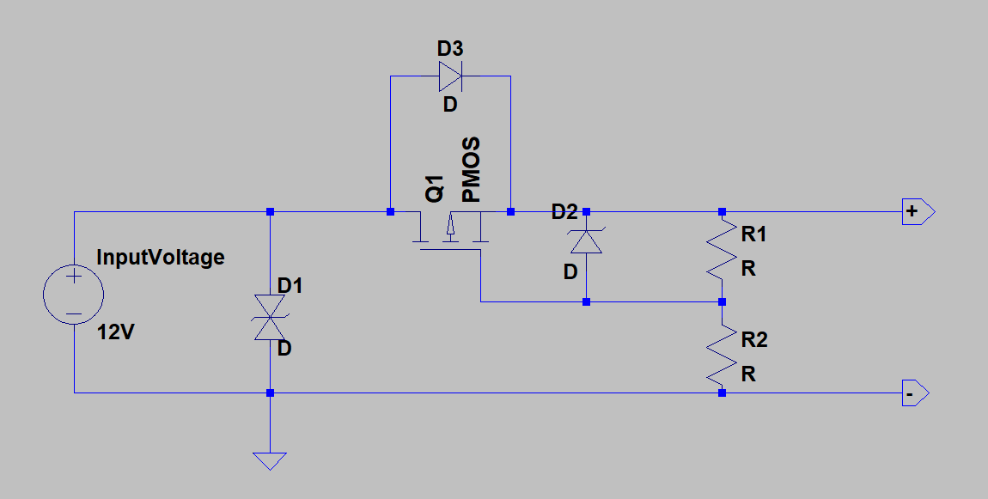

D1 diode is a TVS (Transient Voltage Suppressor) diode, which is like a Zener diode that starts conducting at a defined reverse voltage. What I suggest here is a bidirectional one, which means for example a 40V TVS won’t conduct until it is above + or – 40V. It is there to absorb low power transients and spikes, like ESD or low power engine power transients. It conducts at high voltage and with the help of the transient source output resistance, clamps the voltage below a certain level to protect the circuit.

Now the Q1 MOSFET circuit is what does the rectification for us. In this example Q1 is a P-Channel MOSFET. How it works is like this:

* Imagine everything is off and the output voltage is zero at the beginning.
* When input is applied correctly, the supply voltage passes through the body diode of the MOSFET raising the output voltage.
* As the output rises the gate-source voltage of the MOSFET rises through R1-R2 resistors and so Q1 MOSFET turns on.

Having a MOSFET on is much better than just a diode, because it can be chosen to have very small ON resistance and so wastes very little power compared to a diode.

Now in case of a reverse polarity, if the MOSFET was already off, the body diode of MOSFET also blocks the output from the reverse voltage. R1 keeps the gate-source voltage at zero and the MOSFET remains off. And so, the output is blocked from the reverse input.

If we start from a positive supply and then the supply goes negative:

* MOSFET starts from ON state
* As the input drops, the output drops too as MOSFET is on, and so does the gate-source voltage of MOSFET through R1-R2 resistor
* The MOSFET turns off as input is passing zero and gate-source voltage is zero
* When input is below zero, MOSFET is off and blocks the circuit from reverse voltage

The gate-source voltage of MOSFETs is usually rated for 20V or below. This is the reason for having D2 Zener added to R1-R2 resistors, so that it can clamp the gate-source voltage below 20V. An example of good values is a 16V Zener, 47k for R1 and 10k for R2. The MOSFET should also have a drain-source voltage rating above the maximum reverse voltage.

If your input NEVER rises above 20V gate-source rating, then you can ideally eliminate R1, R2 and D2 and directly connect the MOSFET gate to input negative line.

Also, the MOSFET circuit can be flipped to the ground side using an N-Channel MOSFET. The benefit of N-Ch is that the ON resistance of N-Ch MOSFETs can be much lower than P-Ch, and so can handle much higher currents.

Now every MOSFET has some input capacitance that combined with gate resistors, slows the response time of MOSFET. So, if the input switches from positive to negative super quickly, the MOSFET can conduct for a while in negative voltage if it takes to turn the gate-source voltage off. This could damage the circuit, so:

* Pick R1-R2 that combined with input capacitance of MOSFET, results in a time constant much faster that a negative going transient edge.
* Have large capacitors on the output to absorb high-speed low-power negative transients.
* You can have a reverse diode on the output of the MOSFET, so that it conducts for a very short period it takes for the MOSFET to fully turn off. Such diode won’t blow a fuse as the time it conducts is very short.

One last note on this circuit, if you have large capacitors on the output of the MOSFET, make sure the MOSFET can take the in-rush current required to charge the capacitors.

Option 2:

